***Restaurant Recommending System***

***Applied Data Science Capstone Project***

**18/07/2020**

1. **Introduction:**

**Problem background:**

Bengaluru (also called Bangalore) is the capital of India's southern Karnataka state. The center of India's high-tech industry, the city is also known for its parks and nightlife. By Cubbon Park, Vidhana Soudha is a Neo-Dravidian legislative building. Former royal residences include 19th-century Bangalore Palace, modeled after England’s Windsor Castle, and Tipu Sultan’s Summer Palace, an 18th-century teak structure.

With a population of over 15 million, Bangalore is the Second largest city in India. The diversity of the cuisine available is reflective of the social and economic diversity of Bangalore. Roadside vendors, tea stalls, South Indian, North Indian, Muslim food, Chinese and Western fast food are all very popular in the city. Udupi restaurants, are very popular and serve predominantly vegetarian cuisine. The Chinese food and the Thai food served in most of the restaurants are can be customised to cater to the tastes of the Indian population. Bangalore can also be called a foodie's paradise because of its vast variety of foods and edibles with a touch of Bangalore's uniqueness and tradition.

**Problem description:**

For the people who like travelling and go on vocation very often, for them other than infra and site seeing food is also an important criterion in such situation, food can be an important factor for decided how you rate your trips and plus also recommending it to the people. Food can also attract people around to world to try it out if it were to be the best. In such scenarios, we need to find the right place, at reasonable cost, to serve us the best possible way. So, there are few questions that must be addressed, such as:

1.Varities of foods are available in the restaurant?

2.Nearest restaurant with good rating?

3.How many restaurants are available nearby?

4.Cost and specialty of restaurant?

Expectations from this recommender system is to get answer for the questions, and in such a way that it uncovers all the perspective of managing recommendations. It is sighted to show:

1.Types of restaurants are present in a particular area?

2.where are the similar restaurant present based on a preference to particular food? 3.How do different restaurants rank with respect to my preferences?

**Target Audience:**

Target audiences for this project does not limit to a person who keeps travelling but everyone. People could simply decide to look for a similar restaurant all the time because they are addicted to a specific category of food. People who rarely use restaurants would prefer to have the most rated restaurants nearby them and all this could be easily handled by our recommender system. So, target for this project is basically everyone who is exploring different places or similar places.

**Success rate:**

With restaurants evolving, new food categories emerge, hybrid food starts to be more popular, we need a system that could help us access vast number of food varieties. It is impossible for a person to ask each and every one about their visit to a particular place and also not everyone remembers everything. On the other hand, Computers are good at remembering things, and with Machine learning to its peak, it high time technology will by our personal guidance and help us personally based on our likes and dislikes. So people would care about this project as their personal assistance and success rate could certainly increase with time.

1. **Data:**

**Data requirements:**

To find a solution to the questions and build a recommender model, we need data and lots of data. Data can answer question which are unimaginable and non-answerable by humans because humans do not have the tendency to analyze such large dataset and produce analytics to find a solution.

Suppose I want to find a restaurant, then logically, I need 3 things:

1.Geographical coordinates (latitude and longitude) to find out where exactly it is located. 2.Population of the neighborhood where the restaurant is located.

3.Average income of neighborhood to know how much is the restaurant worth.

Let’s take a closer look at each of these:

1.To access location of a restaurant, its Latitude and Longitude is to be known so that we can point at its coordinates and create a map displaying all the restaurants with its labels respectively.

2.Population of a neighborhood is very important factor in determining a restaurant's growth and number of customers who turn up to eat. Logically, the more the population of a neighborhood, the more people will be interested to walk openly into a restaurant and less the population, a smaller number of people frequently visit a restaurant. Also, if more people visit, better the restaurant is rated because it is accessed by different people with different taste. Hence is very important factor.

3.Income of a neighborhood is also very important factor as population was. Income is directly proportional to richness of a neighborhood. If people in a neighborhood earns more than an average income, then it is very much possible that they will spend more however not always true with very less probability. So an restaurant assessment is proportional to income of a neighborhood.

**Data collection:**

For Geographical coordinates Google maps API has been used to fetch latitude and longitude. But google API has limited number of calls that i could make with my free account. Initially i scrapped list of neighbor's using beautifulSoup4 from wikipedia(<https://en.wikipedia.org/wiki/List_of_neighbourhoods_in_Bangalore>). The table headings becoming the boroughs and data becoming the neighborhoods. Bangalore has 8 boroughs and 64 neighborhoods. So i manually googled each neighborhood to find its corresponding latitude and longitude. After doing so, i produced the following data frame.

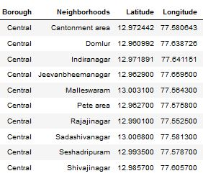

Population by neighborhood for few cities is taken from (<https://indikosh.com/dist/655489/bangalore>) and rest other neighborhood population is assumed and may be inaccurate but since this is a demonstrating project, the main idea is to get the working model. The data frame for Bangalore neighborhood population looks like:

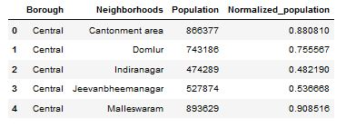

Neighborhood Income is assumed and may be inaccurate but since this is a demonstrating project, the main idea to get the working model. The data frame for Bangalore neighborhood population looks like:

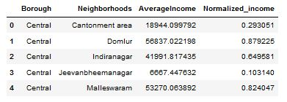

**Foursquare API:**

Use of foursquare is focused to fetch nearest venue locations so that we can use them to form a cluster. Foursquare API leverages the power of finding nearest venues in a radius (in my case: 500mts) and also corresponding coordinates, venue location and names. After calling, the following data frame is created:

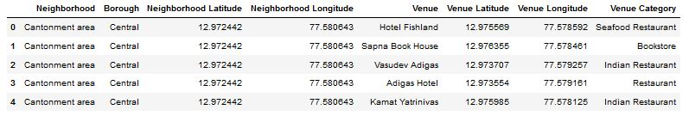

1. **Methodology:**

**Exploratory analysis:**

Scrapping the data from different sources and then combining it to form a single-ton dataset is a difficult task. To do so, we need to explore the current state of dataset and then list up all the features needed to be fetched.

Exploring the dataset is important because it gives you initial insights and may help you to get partial idea of the answers that you are looking to find out from the data.

While exploring the dataset, I found out that Inderanagar has the greatest number of venues while Varthur has the least.

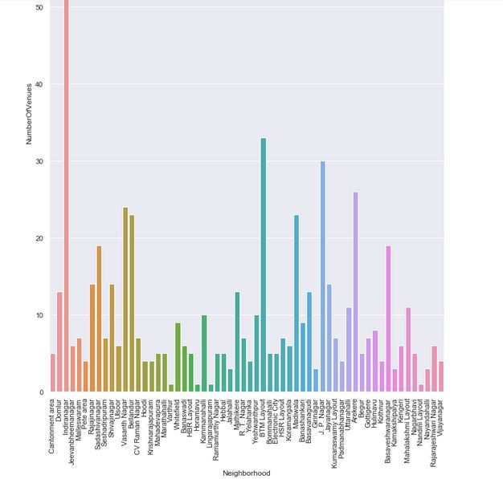

Also, while producing graph for number of clusters, I produced a graph to explore all the values for n_clusters and then finding the best by exploring the elbow graph.

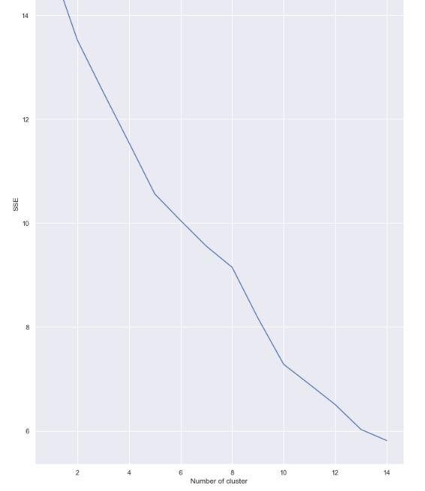

**Inferential analysis:**

Most important factors while building the recommender system were population and income. They are the most import factor because they have a nonlinear relationship according to our dataset.

It needed to make some inferential analysis to understand this nonlinear relationship. As the amount of population increases, it does not necessarily mean that average income of a neighborhood will also increase. It is true to most of the case but also many cases differ to follow this trend. Similarly, a neighborhood with a smaller number of people may not necessarily have less average income. It is possible to have a smaller number of people and more income and vice versa. This can be inferred from the following graph:

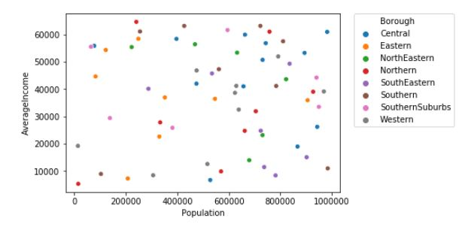

1. **Result:**

The result of the recommender system is that it produces a list of top restaurants and the most common venue item that the user can enjoy. During the runtime of the model, a simulation was done by taking ‘Whitefield’ as the neighborhood and then processed through our model so that it could recommend neighborhoods with similar characters as that of ‘Whitefield’.

The following image shows the result:

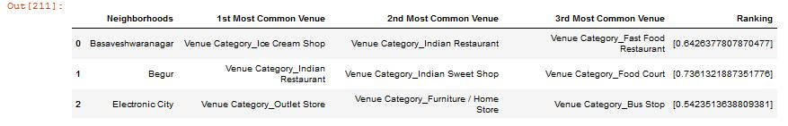

1. **Discussion:**

Since there was a nonlinear relationship between income and population, it can be concluded that we must always perform inferential approach to find relationship among different set of features. Also, during clustering, similar neighborhoods must be dumped into the right cluster.

The following graph shows the clusters:

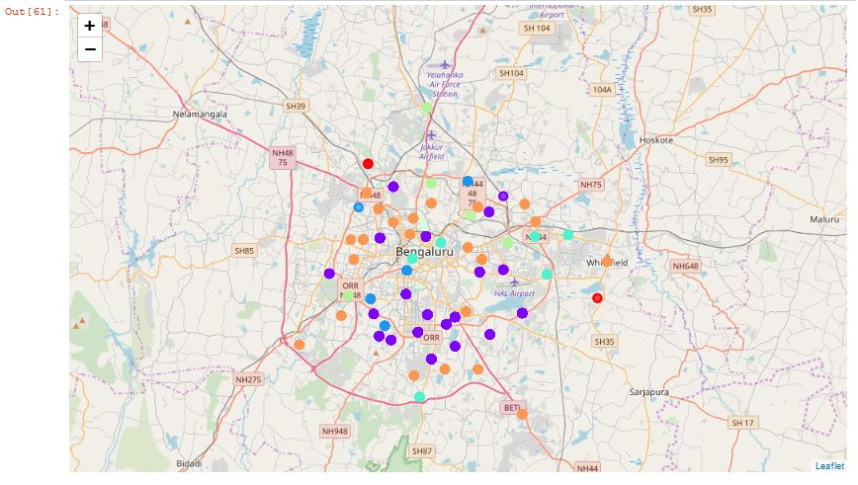

Another observation that we can make is that choosing number of clustering could produce very diverse results. Some may be over fitted or some may be under fitted. Hence analysis of number of clusters must be done. Ref elbow_graph in the Methodology section.

1. **Conclusion:**

The recommender system is a system that considers factors such as population, income and makes use of Foursquare API to determine nearby venues. It is a powerful data driven model whose efficiency may decrease with more data but accuracy will increase. It will help users to finish their hunger by providing the best recommendation to fulfil all their needs.